
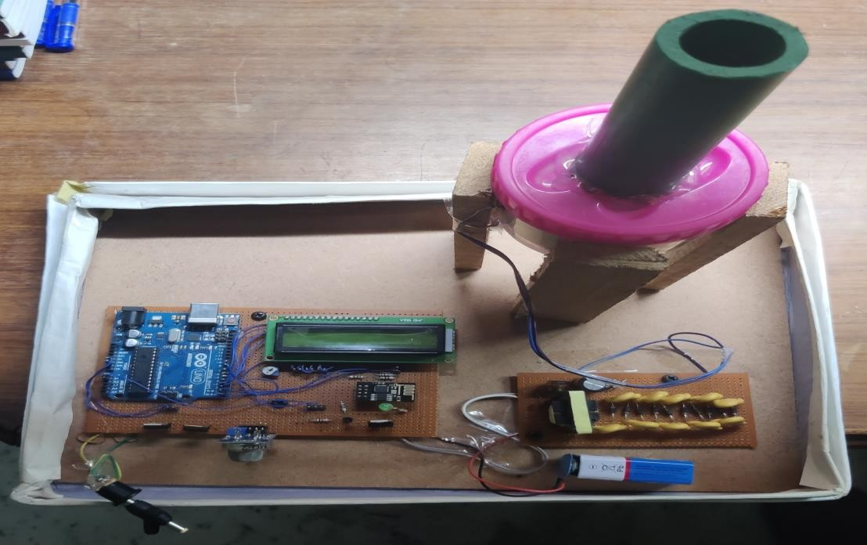
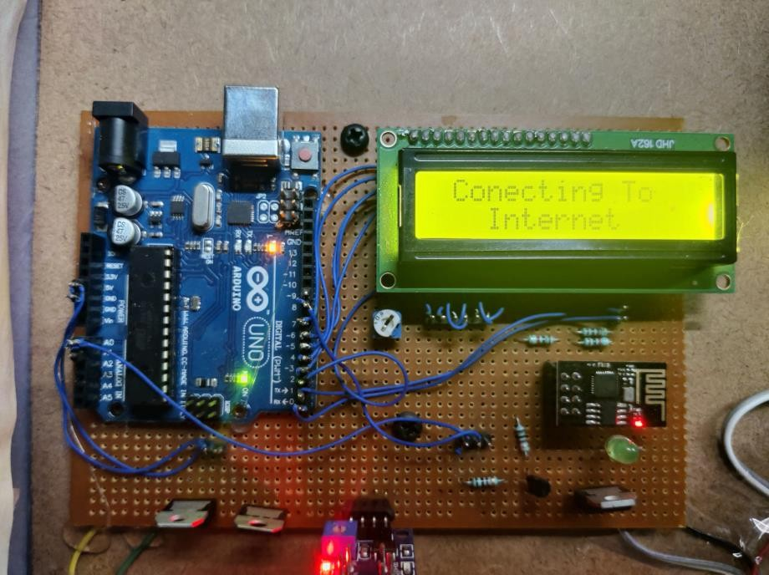
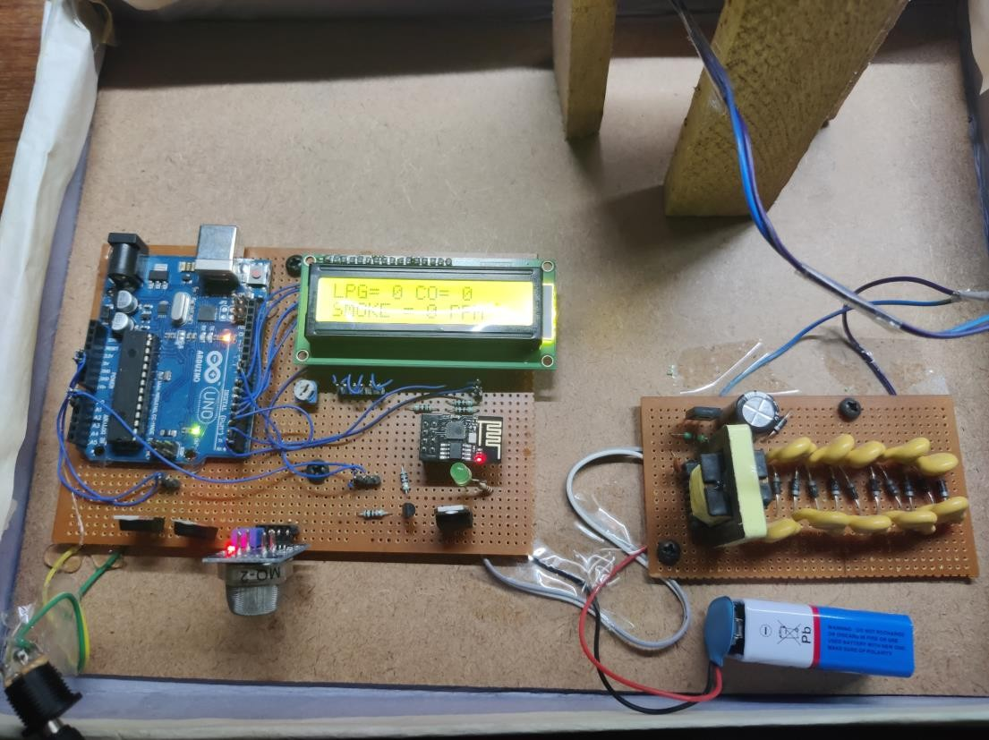
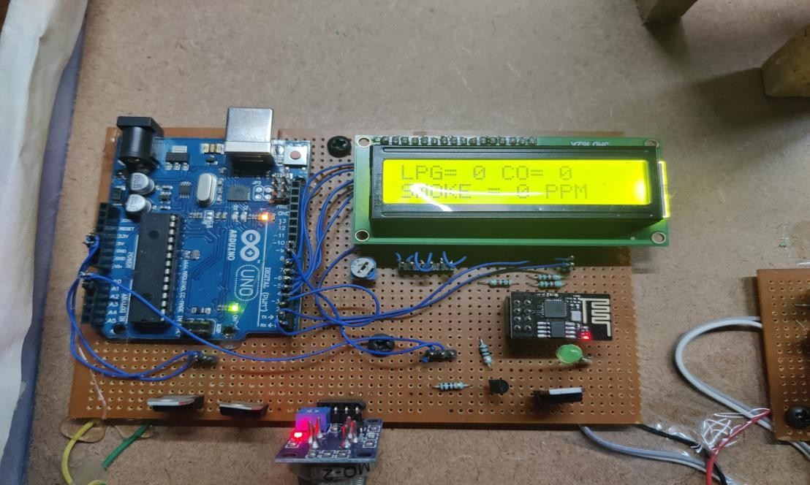
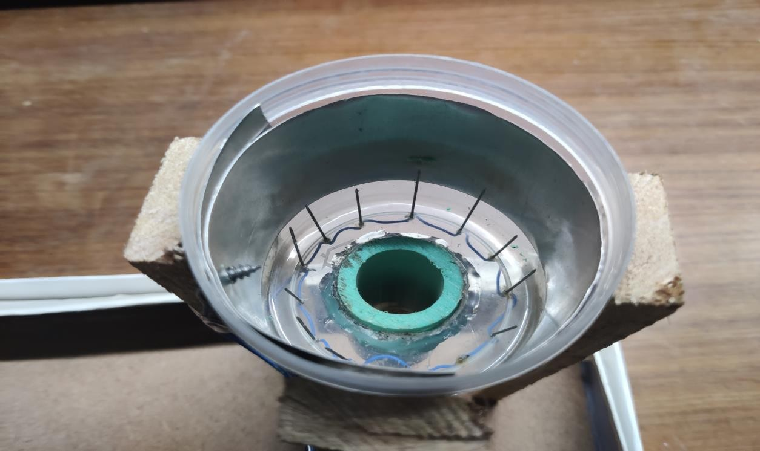
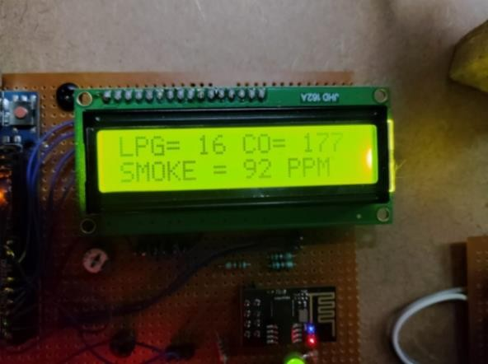
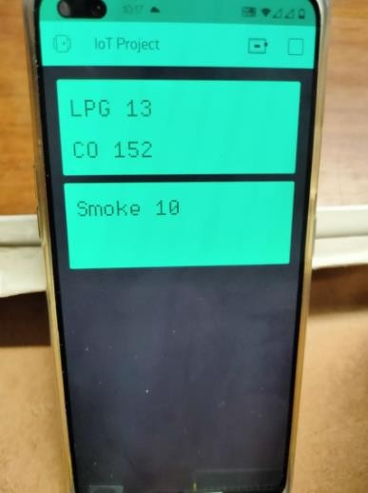
AIR POLLUTION MANAGEMENT

CSE3009-INTERNET OF THINGS

PROJECT BASED COMPONENT REPORT

By

PRAKHAR KHANDURI-19BCE0486

School of Computer Science and Engineering

DECLARATION

We hereby declare that the report entitled “Air Pollution Management” submitted by us, for the CSE3009 Internet Of Things (EPJ) to VIT is a record of bonafide work carried out by me under the supervision of Dr.N.Narayanan Prasanth.
We further declare that the work reported in this report has not been submitted and will not be submitted, either in part or in full, for any other courses in this institute or any other institute or university.

Place: Vellore Date:30th May, 2021

Signature of the Candidate
Pranayan Saha Siddharth Garg Manav Jain Prakhar Khanduri Suraj Kumar

CONTENT | INDEX: | PAGE NO.
List of Figures. |  | 3
ACKNOWLEDGEMENT |  | 4
ABSTRACT INTRODUCTION  i. Objective |  | 4  5
ii. Motivation |  | 5
LITERATURE SURVEY |  | 6
TECHNICAL SPECIFICATION |  | 10
DESIGN |  | 11
PROPOSED SYSTEM |  | 11
RESULTS AND DISCUSSION |  | 12
CONCLUSION |  | 15
REFERENCES |  | 16

LIST OF FIGURES:

Figure No. | Title | Page No.
1. | Entire Setup of the model | 10
2. | Model connecting to the cloud | 11
3 | Boot up of the entire model | 12
4. | LCD displaying the initial readings | 12
5. | Inside of the ESP air purifier | 13
6. | Readings of the pollution levels | 13
7. | Pollution values on the Blynk app | 14

ACKNOWLEDGEMENT:

This paper and the research behind it would not have been possible without the exceptional support of my supervisor, Prof.Narayanan Prasanth N. His enthusiasm, knowledge and exacting attention to detail have been an inspiration and kept our work on track. All my teammates equally contributed till the final draft of this paper. The generosity and expertise of one and all have improved this study in innumerable ways and saved us from many errors. We are thankful to Vellore Institute of Technology for providing us with this wonderful opportunity.

ABSTRACT:

Over the past quarter century, there has been an exponential growth in the number of industries. These industries have caused complex and serious problems to the environment mainly with air pollution. Considering the significance of air quality on human lives, the World Health Organization (WHO) has developed guidelines for reducing the health effects of air pollution on public health by setting the limits of the concentrations of various air pollutants, some of which are ground–level ozone (O3), nitrogen dioxide (NO2), and sulfur dioxide (SO2). The first and the foremost is the severe environmental pollution which has caused deterioration of atmosphere, climate change, stratospheric ozone depletion, loss of biodiversity, changes in hydrological systems and the supplies of fresh water, land degradation and stress on systems of food producing, acid rain, and global warming.
Stationary and mobile sources release various chemical pollutants, including suspended particulate matter (SPM), carbon monoxide (CO), oxides of nitrogen (NO), oxides of sulfur (SO ), lead aerosol, volatile organic compounds (VOC), and other toxics. It is well known that some of these chemical pollutants have increased the occurrence of diseases such as lung cancer, pneumonia, asthma, chronic bronchitis, coronary artery disease, and chronic pulmonary diseases. Hence, there is a growing demand for environmental pollution monitoring systems in recent years.

In view of the ever-increasing pollution sources with toxic chemicals, these systems should have the facilities to detect and quantify the sources rapidly. Using laboratory analysis, the conventional automatic air monitoring system has relatively complex equipment technology, large bulk, unstable operation and high cost. High cost and large bulk make it impossible for large-scale installation. This system can only be installed in key monitoring locations of some key enterprises; thus, system data is unavailable to predict overall pollution situation. To overcome the defects of traditional monitoring system and detection methods and to reduce test cost, this work proposes a method combining IoT technology with environment monitoring

INTRODUCTION:

Objective:

A prototype for an Environmental Air Pollution Monitoring System for monitoring the concentrations of major air pollutant gases has been developed. The system uses low-cost air- quality monitoring nodes which comprises low-cost Gas sensor (MQ2) connected with Arduino. This system measures concentrations of gases such as carbon monoxide, LPG and smokes using sensors. The sensors will gather the data of various environmental parameters and provide it to Microcontroller based Arduino, which acts as a base station. Realization of data gathered by sensors is displayed on LCD displays through Serial communication. The Wi-Fi connectivity is also provided by ESP8266 Wi-Fi module, to interact with Mobile phone / Laptop (Blynk mobile application) for remote monitoring and controlling of the system. The system is developed to display data over an application. The fundamental aspect of the proposed work is to provide low-cost infrastructure to enable the monitoring of air to gather the information about the major pollutants in it.

The objective is to design and implement an efficient system for air pollution monitoring in a given area. The system would measure the concentration of dangerous gases in ppm with the help of a Gas Sensor & Arduino, and would store and transmit data through ESP8266 to the Blynk application. Also, with a major update, we implemented an air purifier to purify the gas input.

Motivation:

The atmosphere is a chaotic system, air condition is influenced by many factors and can change quickly. Air condition and quality directly affect people’s daily lives, such as their commute to work and the safety of outdoor activities. With the awareness of more and more serious air pollution in many countries growing, there is an increasing demand for a more efficient way to observe, record and collect air quality data. Usually, people will obtain atmospheric conditions from weather forecasts, but these can only provide limited information in any given location, and are not very accurate. Although there are some advanced systems that might be able to monitor more atmospheric parameters, these systems usually generalize their measurements over a very large area, for instance, monitoring real time parameters for a metropolitan area or a large suburb using a few observation points.

LITERATURE SURVEY:

- loT based air pollution monitoring and control system
Authors- S.Muthukumar, W.Sherine Mary, Jayanthi.S, Kiruthiga.R, Mahalakshmi.M.DOI- 10.1109/ICI RCA.2018.8597240 Date of Conference: 11-12 July 2018 Publisher: IEEE

Their work considers air pollution caused due to automobiles and provides a real time solution which not just monitors pollution levels but also takes into consideration control measures for reducing traffic in highly polluted areas.
They design a sensor-based hardware module which can be placed along roads. These modules can be placed on lamp posts and they transfer information about air quality wirelessly to remote servers. This information can be used for traffic control using mobile apps.

They used Arduino-UNO based microcontroller, Gas Sensor MQ-2, Wi-Fi Module ESP8266, LCD display, Electrostatic Precipitator (ESP) type Air Purifier.

- Towards a Smart Sustainable City: Air Pollution Detection and Control using Internet of Things
Authors- Mohamed Ghoneim, Sahar M. Hamed.DOI- 10.1109/ICOA. 2019.8727690 Date Added to IEEE Xplore: 03 June 2019

This paper suggests a green loT-based efficient system that detects and monitors the outdoor air pollution level. The system is also powered by renewable energy.To maintain the functionality of loT devices, they require sufficient energy which is considered a challenge. To overcome that challenge in IoT-based smart cities, the sensing devices must operate with low power consumption and at a very low cost. Hence, the concept of green loT has emerged. This system would sense the pollution level in the surrounding atmosphere and compare it to the pollution safety limit. If the pollution level is higher than that limit, the purifier system gets turned on till the pollution level reaches the safe limit, then gets turned off.

They used Amperometric sensor (nitrogen dioxide, carbon monoxide sensor), Electrochemical sensor (sulfur dioxide, ozone sensor).
- Design and Implementation of Portable Sensory System for Air Pollution Monitoring Author- Xuan Zhao, Siming Zuo, Rami Ghannam, Qammer H. Abbasi and Hadi Heidari DOI: 10.1109/PRIMEASIA.2018.8597655 Date of Conference: 26-30 Oct. 2018

This paper focuses on the design and fabrication of a portable sensory system for air pollution monitoring, which can detect the temperature, humidity and particulate matter (PM). The traditional air pollution monitoring stations use bulky and expensive instruments installed in limited areas, useless for people to monitor their surrounding environment in real time. Thus, the portable air quality sensors having the potential to fill in the gap left by traditional monitoring are required nowadays.
In this paper, an optical sensor for repeated detection of the dust pollution in real time is introduced. The system structure is based on the two sensors GP2Y1010AU0F dust sensor which collects the concentration of PM2.5 in the air while the DHT11 sensor collects the humidity and temperature data.
Dust sensor with higher sensitivity could be adopted to increase the reliability of this device. In addition to PM2.5, there are also many gases that cause air pollution such as NO, S02, 03 which could also be detected.

- A IOT Controlled Cloud Based Air and Sound Pollution Monitoring System with Temperature and Humidity Sensing
Authors- Arnab Kumar Saha,Sachet Sircar,Priyasha Chatterjee,Souvik Dutta,Anwesha Mitra,Aiswarya Chatterjee,Soummyo Priyo Chattopadhyay, Himadri Nath Saha.DOI- 10.1109/CCWC. 2018.8301660

An loT-based method to monitor the Air Quality Index and the Noise Intensity of a region, has been proposed. The recommended technology comprises four modules namely, the Air Quality Index Monitoring Module, the Sound Intensity Detection Module, the Cloud-based Monitoring Module and the Anomaly Notification Module.
Air Quality Index is measured depending on five criteria pollutants, namely, ground-level ozone, particulate matter, Carbon monoxide, Sulphur Dioxide and nitrogen dioxide. In this project we are using MQ -135 AIR QUALITY or GAS DETECTION SENSOR. It efficiently detects the NH3, NOx, smoke and C02 level in air. This specific sensor is chosen for its expansive detecting scope, fast response, reliability and long-term stability. The proposed method involves cloud based monitoring of the required parameters with the help of the internet. The alert system ensures that the user is notified about any unfavorable condition which demands instant action.
They need to implement the concept of machine learning so that we can forecast the possible environmental data. It gives an estimate of the upcoming weather conditions and creates awareness amongst the public.

- Mapping urban air quality using mobile sampling with low-cost sensors and machine learning in Seoul, South Korea
Authors- Chris C.Lim, HoKim, M.J. Ruzmyn Vilcassim, George D.Thurston, Terry Gordon, Lung-ChiChen, Kiyoung Lee, Michael Heimbinder, Sun-Young Kim

A machine-learning based IoT project has been developed to map and monitor the air quality over different routes in a given area using low-cost sensors.Land use regression (LUR) model, constructed by linear regression, random forest and stacked ensemble, is used to depict the variability in PM 2.5 concentrations over a given region and identify the pollution hotspots, by collecting data for 169 hours over 3 weeks.
They used Particle Sensor (PPD60PV-T2 ), Android smartphone, Aerosol Monitor (DataRAM pDR-1500)
There is no apparent loophole that we were able to identify in this project as such, but the highly complex and difficult-to-understand nature of the implementation does put it at a disadvantage in front of those lacking the appropriate knowledge of Machine Learning.

- Arduino-Based Real Time Air Quality and Pollution Monitoring System
Saumendu Roy, A. H. M. Saim, Rozina Akter, Md. Zakir Hossain, Md. Abdullah Al Ahasan ISSN: 2347-5552, Volume-6, Issue-4, July 2018.

Most of the major cities in developing countries and most cities of the developed countries are suffering from it. Thus to develop a real time air quality and pollution monitoring system is critical. We have developed an arduino based air pollution detector which combines a small-sized,minimum-cost sensor to an arduino microcontroller unit. The advantages of the detector are reliable stability, rapid response recovery and long-life features. It is affordable, user-friendly, low-cost and minimum-power requirement hardware which is appropriate for mobile measurement, as well as comprehensible data collection. It has processing software able to analyze, collected quality data with high precision. Simple instrument which can be commercially utilized.

- Arduino and Sensor Based Air Pollution Monitoring System Using IOT by Mahesh V. Walsange 1, Prof. Yerigeri, Department of Post-Graduation, MBES COE Ambajogai (MS), India.

Internet of Things (IoT) may be a worldwide system of “smart devices” which will sense and connect with their surroundings and interact with users and other systems. Global pollution is one among the main concerns of our era. Existing monitoring systems have inferior precision, low sensitivity, and need laboratory analysis. Therefore, improved monitoring systems are needed. To overcome the issues of existing systems, we propose a three-phase pollution monitoring system. An IoT kit was prepared using some sensors, Arduino IDE (Integrated Development Environment), and a Wi-Fi module. These kits are often physically placed in various cities to monitor pollution. The sensors gather data from air and forward the data to the Arduino IDE. The Arduino IDE transmits the info to the cloud via the Wi-Fi module. It can be monitored from android mobile phone also. The proposed system is to predict quality of air using different sensors and stored data in the database and cloud so any one can retrieve
data from anywhere anytime. Furthermore, air quality data are often wont to predict future air quality index (AQI) levels.

- Low Cost IoT Based Air Quality Monitoring Setup Using Arduino and MQ Series Sensors With Dataset Analysis
Kinnera Bharath Kumar Sai, Subhaditya Mukherjee, H Parveen Sultana

The Internet of Things is nowadays finding insightful use in almost every sector of human society. Therefore, IOT can also play a key and conclusive role in monitoring the air which we breathe. IOT combined with cloud computing, can offer a sophisticated system for better and efficient supervision of data coming from different sensors which can be collected and transmitted by low power source. While using pragmatic analysis, the conventional monitoring system may have a high precision, but it comes with the downside of being large, bulky and having high cost which make it impossible for large-scale implementation and installation.

- A System for monitoring air and sound pollution using Arduino Controller with IoT technology L.Ezhilarasi, K.Sripriya, A .Suganya , K. Vinodhini (Ganadipathy Tulsi’s Jain Engineering College,Vellore) IRJAET - VOL 3 ISSUE 2, 2017 (ISSN : 2454-4744)

The proposed embedded device for monitoring noise and air levels in the atmosphere to make the environment intelligent or interactive with objects. The proposed model is adaptable and distributive in nature to monitor the environmental parameters. The architecture is developed for noise and air pollution monitoring. Smart sensor networks are the emerging field of research which combines many challenges of computer science, wireless communication and electronics.

- IOT-based Air Pollution Monitoring System
Devahema, P.V. Sai Surya Vamsi, Archit Garg, Abhinav Anand, Desu Rajasekhar Gupta (SRM Institute of Science & Technology, Chennai, India),JNCET Volume 8, Issue 4, April, 2018 (ISSN: 2395-5317)

The level of pollution has increased with time due to a lot of factors like the increase in population, increased vehicle use, industrialization and urbanization which results in harmful effects on human wellbeing by directly affecting the health of the population exposed to it. In IOT Based Air Pollution Monitoring System the Air Quality is measured over a web server using internet and will trigger a alarm when the air quality goes down beyond a certain level, means when there are sufficient amount of harmful gases are present in the air like CO2, smoke ,alcohol, benzene and NH3.It will show the air quality in PPM on the LCD and as well as on webpage so that we can monitor it very easily. sensor which is the best choice for monitoring Air Quality as it can detect most harmful gases and can measure their amount accurately .The pollution level can be monitored anywhere using a computer or mobile.
Install this system anywhere and can also trigger some device when pollution goes beyond some level, like it can switch on the Exhaust fan or can send alerts.

TECHNICAL SPECIFICATION:

Hardware Specification:
  - Intel i7-7100U CPU 10th Gen Processor
  - Clock Speed @2.40GHz
  - RAM 8.00 GB
  - Intel HD Graphics 620
  - Arduino UNO.
  - 16*2 Character LCD
  - ESP8266 Wi-Fi Module
  - MQ-2 Sensor.
  - Resistors.
  - Capacitors.
h) Air purifier.

Software Specification:
- Blynk application
- Microsoft Windows 10 Education 64-bit.
- Arduino IDE.

DESIGN:
Fig.1.Entire setup of the model

PROPOSED SYSTEM:

This system measures concentrations of gases such as carbon monoxide, LPG and smokes using sensors. The sensors will gather the data of various environmental parameters and provide it to Microcontroller based Arduino, which acts as a base station. Realization of data gathered by sensors is displayed on LCD displays through Serial communication. The Wi-Fi connectivity is also provided by ESP8266 Wi-Fi module, to interact with Mobile phone / Laptop (Blynk mobile application) for remote monitoring and controlling of the system. The system is developed to display data over the application. The fundamental aspect of the proposed work is to provide low-cost infrastructure to enable the monitoring of air to gather the information about the major pollutants in it. Not only this, but also purifying the gas input has been a major part of our model.

RESULTS AND DISCUSSION:

Fig 2: Model connecting to the internet.
Fig 3. Boot up of the entire model

Fig 4. Initial readings of the model.

Fig 5. Inside of the ESP Air Purifier

Fig 6. Readings after a source of pollutant is brought near the MQ2

Fig 7. The live pollution readings are seen on the Blynk app also

Demonstration Video: Google Drive Link

Firstly, we are providing a DC circuit of 12 V power supply, which in turn is connected to two regulators (7805 voltage regulators). One regulator for the MQ-2 sensor for sensing the data, and the other is for the entire circuit which is used to convert the 12V power supply to 5V, connected to Arduino. Had there been only one regulator, this would have the heat up the MQ-2 sensor. So, two regulators are must for the entire model to circuit without any heating up.MQ-2’s analog output is input in A0 pin in Arduino, and also the LCD is also been connected to the Arduino UNO board. Three resistors are connected to the RX pins since the data fluctuates, and so this resistors makes it stable and manages the readings. The TIP is used to turn on/off the purifier. Here, the Arduino’s output comes to the transistor’s base, and then the transistor turns on/off the TIP. The other circuit part is for managing the air purifier which consists of a transformer, some diodes and a capacitor. The purifier uses aluminium rods to ionize and purify the air.
So, when the MQ-2 sensor senses any input smoke/air, it displays the readings of LPG, CO and smoke in the LCD screen as well as in the Blynk application for real-time readings, and sensing the smoke, the air purifier tends to purify the air if the smoke value goes above 50 ppm.

CONCLUSION:

The presence of dust in homes, offices, and other human environments are unavoidable. In fact, according to the Environmental Protection Agency, indoor air can be 2 to 5 times more polluted than outdoor air. This airborne pollution contributes to minor annoyances such as itchy eyes, sneezing, and headaches to human beings. Worst still, it can be a major contributing factor to severe allergies, life-threatening asthma.

It is now important to monitor air pollution in real time in most of the urban areas. This project is aimed at developing an IOT device which can monitor air pollution in real time and log data to a remote server. Remote monitoring was facilitated using classical motes in the past, which has some pitfalls like limited memory, processing speed and complex programming strategies. By using Internet of Things and recording sensor data to a remote server, the limitations of memory in the monitoring devices and manual collection of data from the installed devices can be overcome. The IOT also helps monitoring the data in real time.

REFERENCES:

- loT based air pollution monitoring and control system
Authors- S.Muthukumar, W.Sherine Mary, Jayanthi.S, Kiruthiga.R, Mahalakshmi.M.DOI- 10.1109/ICI RCA.2018.8597240 Date of Conference: 11-12 July 2018 Publisher: IEEE.

- Towards a Smart Sustainable City: Air Pollution Detection and Control using Internet of Things
Authors- Mohamed Ghoneim, Sahar M. Hamed.DOI- 10.1109/ICOA. 2019.8727690 Date Added to IEEE Xplore: 03 June 2019

- Design and Implementation of Portable Sensory System for Air Pollution Monitoring Author- Xuan Zhao, Siming Zuo, Rami Ghannam, Qammer H. Abbasi and Hadi Heidari DOI: 10.1109/PRIMEASIA.2018.8597655 Date of Conference: 26-30 Oct. 2018

[4]A IOT Controlled Cloud Based Air and Sound Pollution Monitoring System with Temperature and Humidity Sensing
Authors- Arnab Kumar Saha,Sachet Sircar,Priyasha Chatterjee,Souvik Dutta,Anwesha Mitra,Aiswarya Chatterjee,Soummyo Priyo Chattopadhyay, Himadri Nath Saha.DOI- 10.1109/CCWC. 2018.8301660

- Mapping urban air quality using mobile sampling with low-cost sensors and machine learning in Seoul, South Korea
Authors- Chris C.Lim, HoKim, M.J. Ruzmyn Vilcassim, George D.Thurston, Terry Gordon,
Lung-ChiChen, Kiyoung Lee, Michael Heimbinder, Sun-Young Kim

- Arduino-Based Real Time Air Quality and Pollution Monitoring System
Saumendu Roy, A. H. M. Saim, Rozina Akter, Md. Zakir Hossain, Md. Abdullah Al Ahasan ISSN: 2347-5552, Volume-6, Issue-4, July 2018.

- Arduino and Sensor Based Air Pollution Monitoring System Using IOT by Mahesh V. Walsange 1, Prof. Yerigeri, Department of Post-Graduation, MBES COE Ambajogai (MS), India.

- Low Cost IoT Based Air Quality Monitoring Setup Using Arduino and MQ Series Sensors With Dataset Analysis
Kinnera Bharath Kumar Sai, Subhaditya Mukherjee, H Parveen Sultana

[9]A System for monitoring air and sound pollution using Arduino Controller with IoT technology L.Ezhilarasi, K.Sripriya, A .Suganya , K. Vinodhini (Ganadipathy Tulsi’s Jain Engineering College,Vellore) IRJAET - VOL 3 ISSUE 2, 2017 (ISSN : 2454-4744)
[10]IOT-based Air Pollution Monitoring System
Devahema, P.V. Sai Surya Vamsi, Archit Garg, Abhinav Anand, Desu Rajasekhar Gupta (SRM Institute of Science & Technology, Chennai, India),JNCET Volume 8, Issue 4, April, 2018 (ISSN: 2395-5317)

